**Stage 2 - “The suspense is terrible… I hope it’ll last”**

**COURSE DESIGNER:** Ryan Christenson

|  |
| --- |
| **SCORING:** Comstock 30 rounds.  **TARGETS:** 15 cardboard targets.  **SCORED HITS:** 2 Best hits per carboard will be scored. |

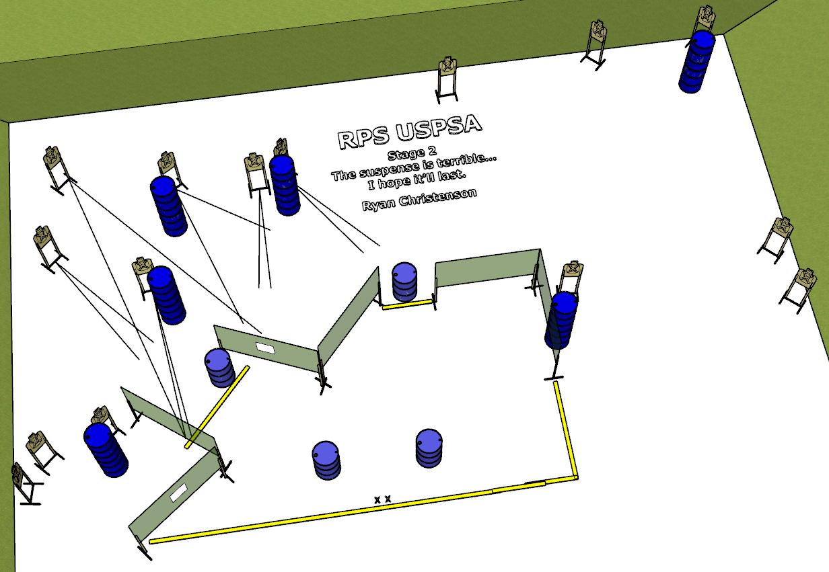

**Written Stage Briefing:**

**Stage 2 - “The suspense is terrible… I hope it’ll last” -** is a 30-round, 150 point, Comstock Long Course. There are 15 cardboard targets. The best 2 hits per cardboard target will be scored.

**Start position** Both feet on the Shooting Sports Innovations Xs, facing downrange.

**Firearm**: Unloaded and placed un-propped on Barrel A or B.

All magazines / reloading devices to be used for the stage must be placed on the remaining barrels prior to the start signal.

On the audible start signal, engage targets from within the shooting area.

**USPSA / NROI Range Commands:**

* Make Ready
* Are you ready?
* Standby
* If finished, unload and show clear.
* If clear, hammer down and holster
* Range is clear

**Setup Notes:**

6 Single Wall Stands

3 Double Wall Stands

4 Full Walls

2 Port Walls

15 Target stands / 30 target sticks

16+ barrels

